Hitchhiker's guide to cinema

Final Report

Introduction
Hitchhikers guide to cinema (h2gc) is a web page relying on the internet movie database (IMDb) Rest API to perform various searches. Search filters are already provided by the official web page and the related app (limited), but the most complexes search criteria are not easily reachable (not present in app, not directly accessible from the web-page) and the forms to perform searches are not too satisfying (especially from mobile devices).
H2gc’s goal is to provide a lightweight responsive page to perform searches easily.

For further info about the original projects, features and goals, please refer to the doc related to the previous steps of the project (related to Bootstrap course) available in:
https://bitbucket.org/sterte/h2gc/src/master/doc/Course%201%20-%20Bootstrap/

Design and Implementation
The initial idea was to keep mockup pages and navigation structure defined in the original project (related to Bootstrap course) while “translating” it in React as a single page app.
The original wireframe mockup are available at: https://bitbucket.org/sterte/h2gc/src/master/doc/Course%201%20-%20Bootstrap/Hitchickers%20guide%20to%20cinema%20-%20UI%20prototiping.pdf

The prototype web-pages can be seen at: https://h2gc-react.web.app/

The basic structure isn’t changed, but everything have been translated in a React app. From the user point of view very few is changed: animation while loading data and switching pages/components and some other little features.
The real difference from the initial Bootstrap project is under the hood: the redefinition of H2GC as a Single Page React App led toward a modularity of the components used and to the use of a (sort of) Rest API via fetch. This allowed to move the first steps toward a backend/db and to start dealing with problems regarding that: asynchronous data loading, dynamic rendering of pages (the bootstrap version was completely static content)

Some screenshot of the current state of the project follow:

Homepage: the data visualized is actually fetched from a minimal Rest API, divided in released and imminent released (flag used to test, with no veridicity at all with respect to actual movies’ releases).
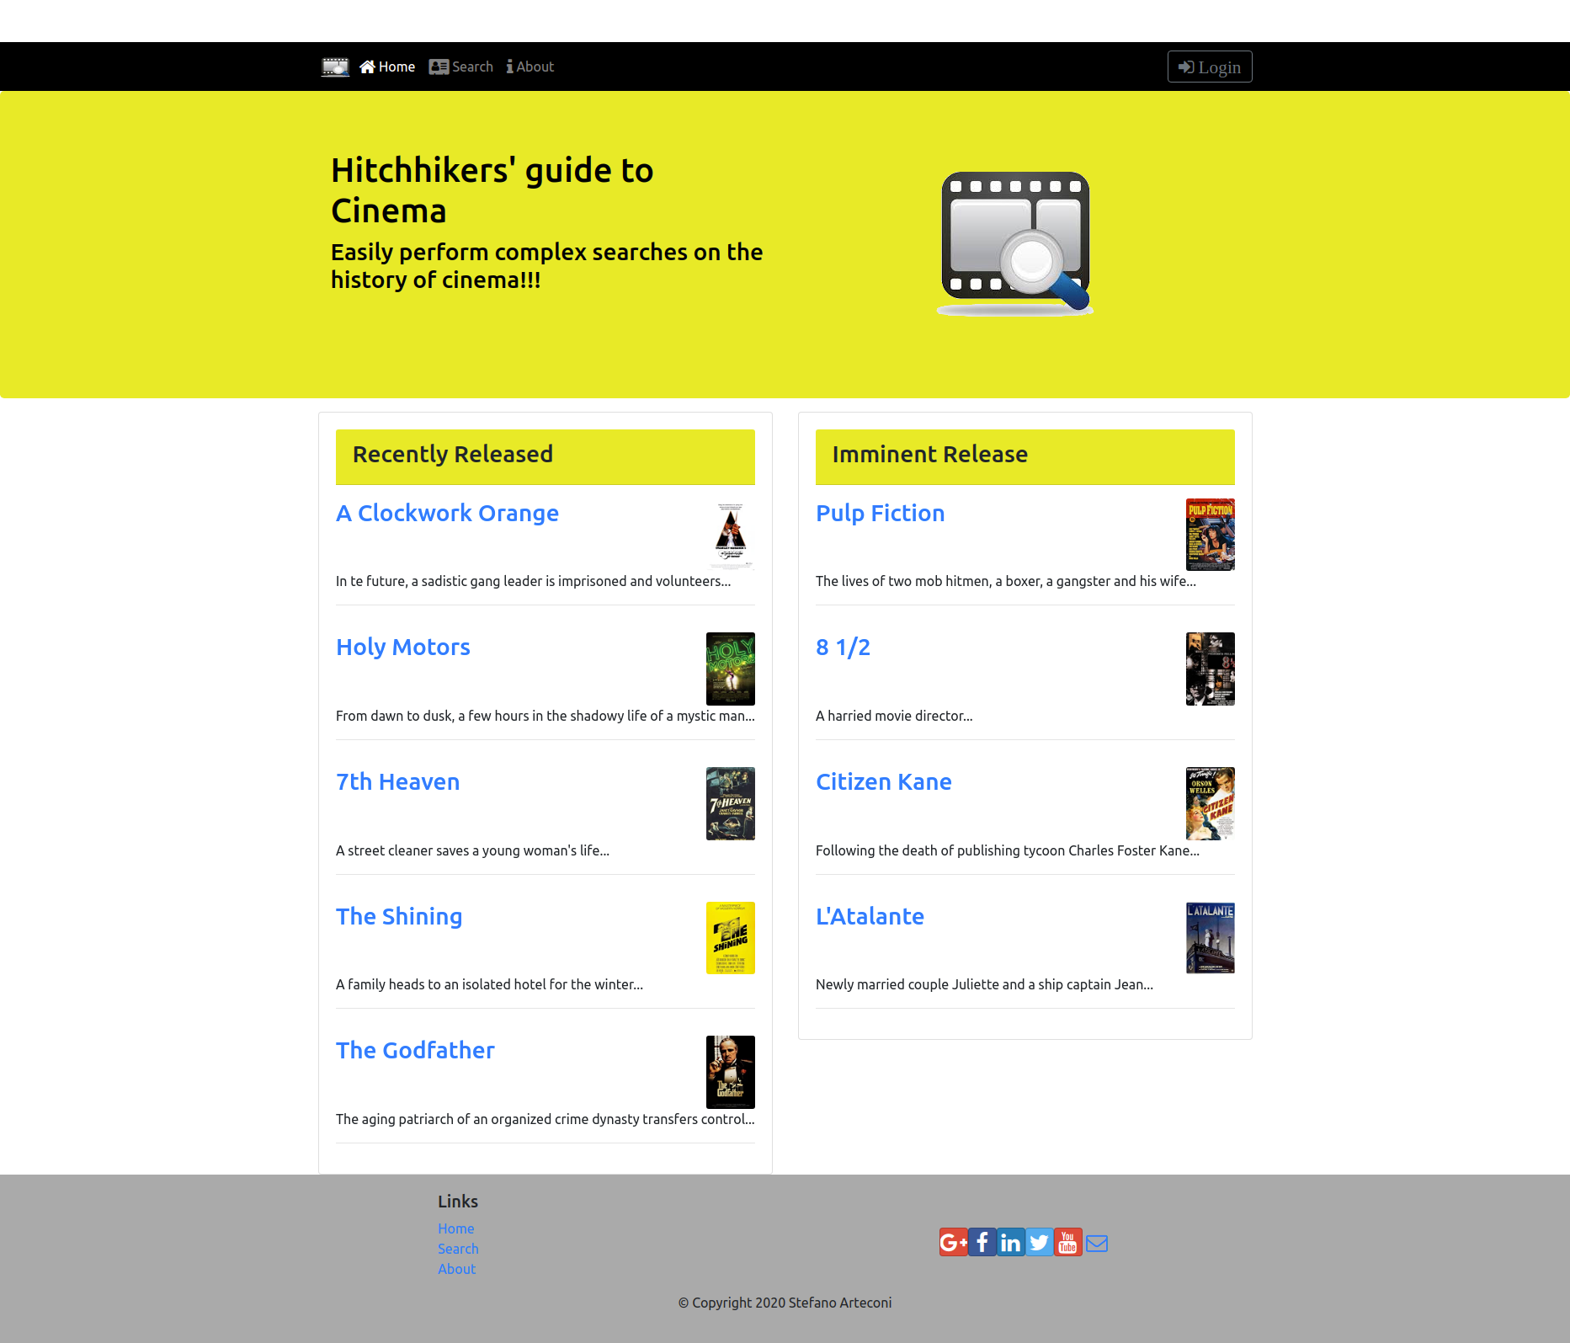

Movie detail page: data filled dynamically, just a proof of concept, the page will contain more info (i.e. crew/cast).
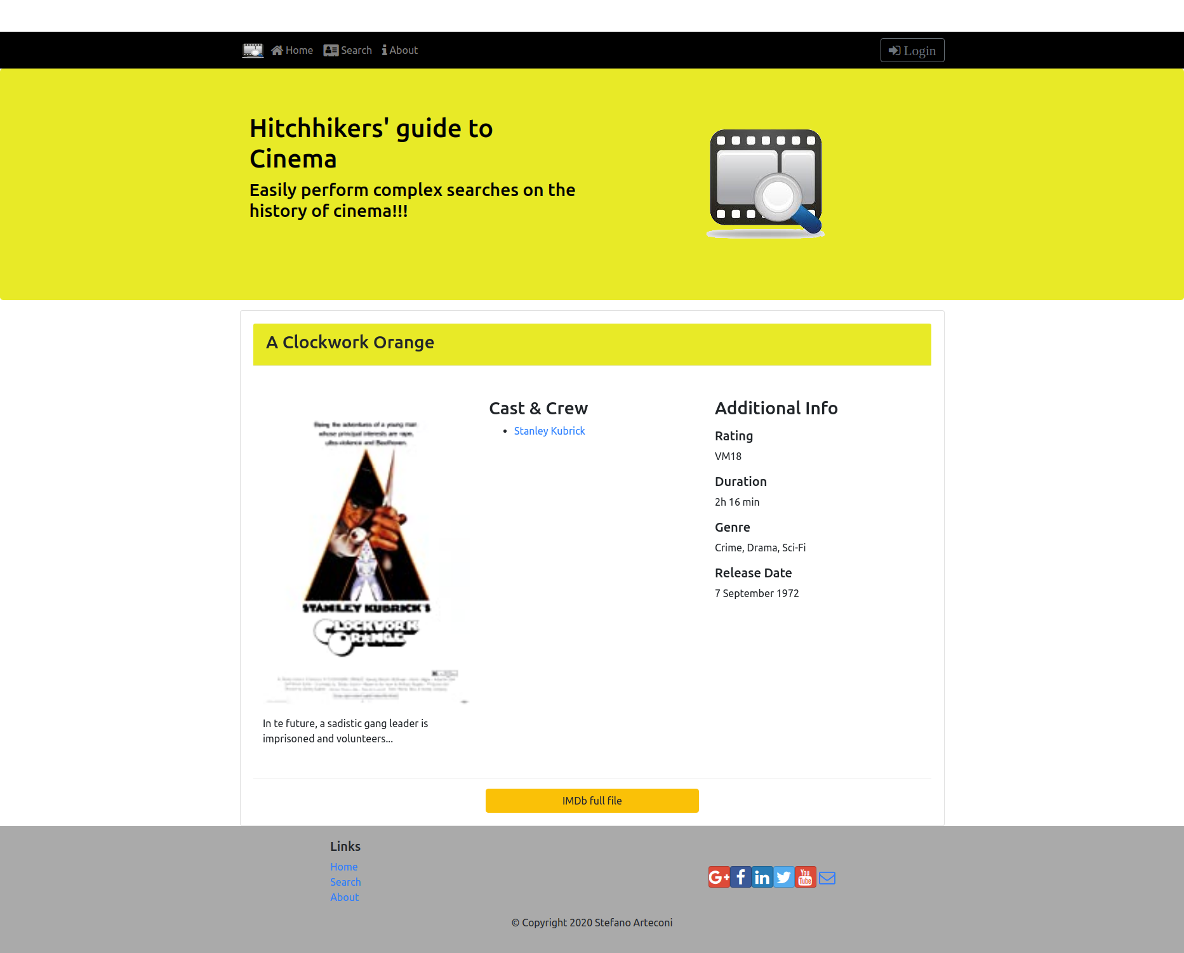

Person detail page, analogue to movie:
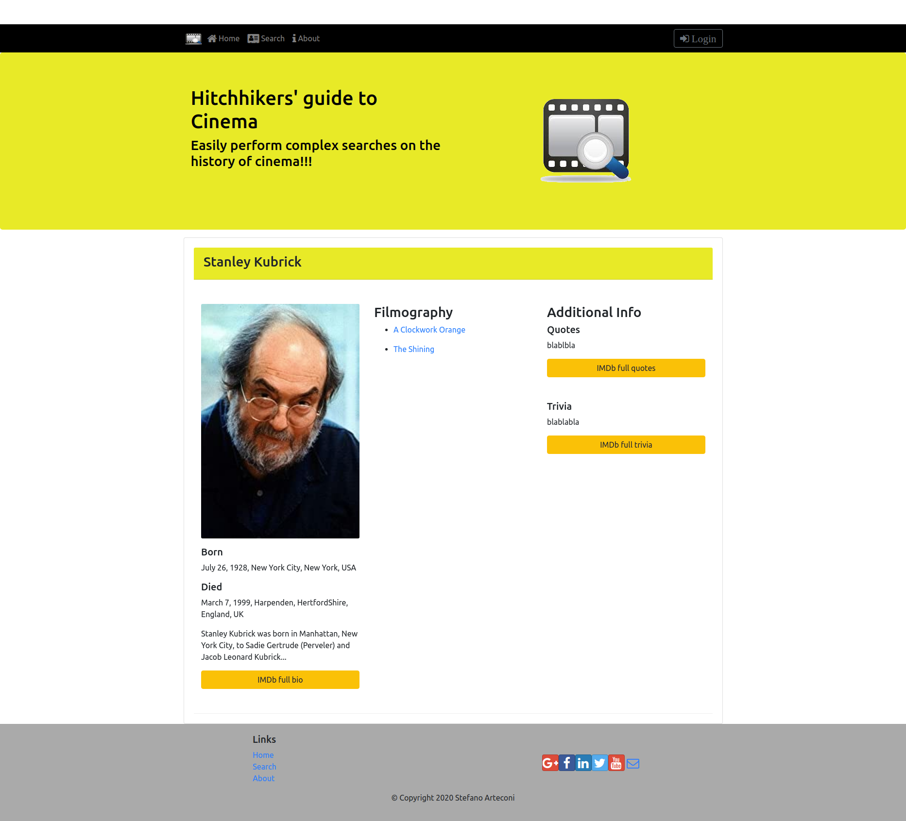

Search forms are still at a primitive state, when actual query to real Rest API will be performed, search forms will be developed and detailed accordingly:
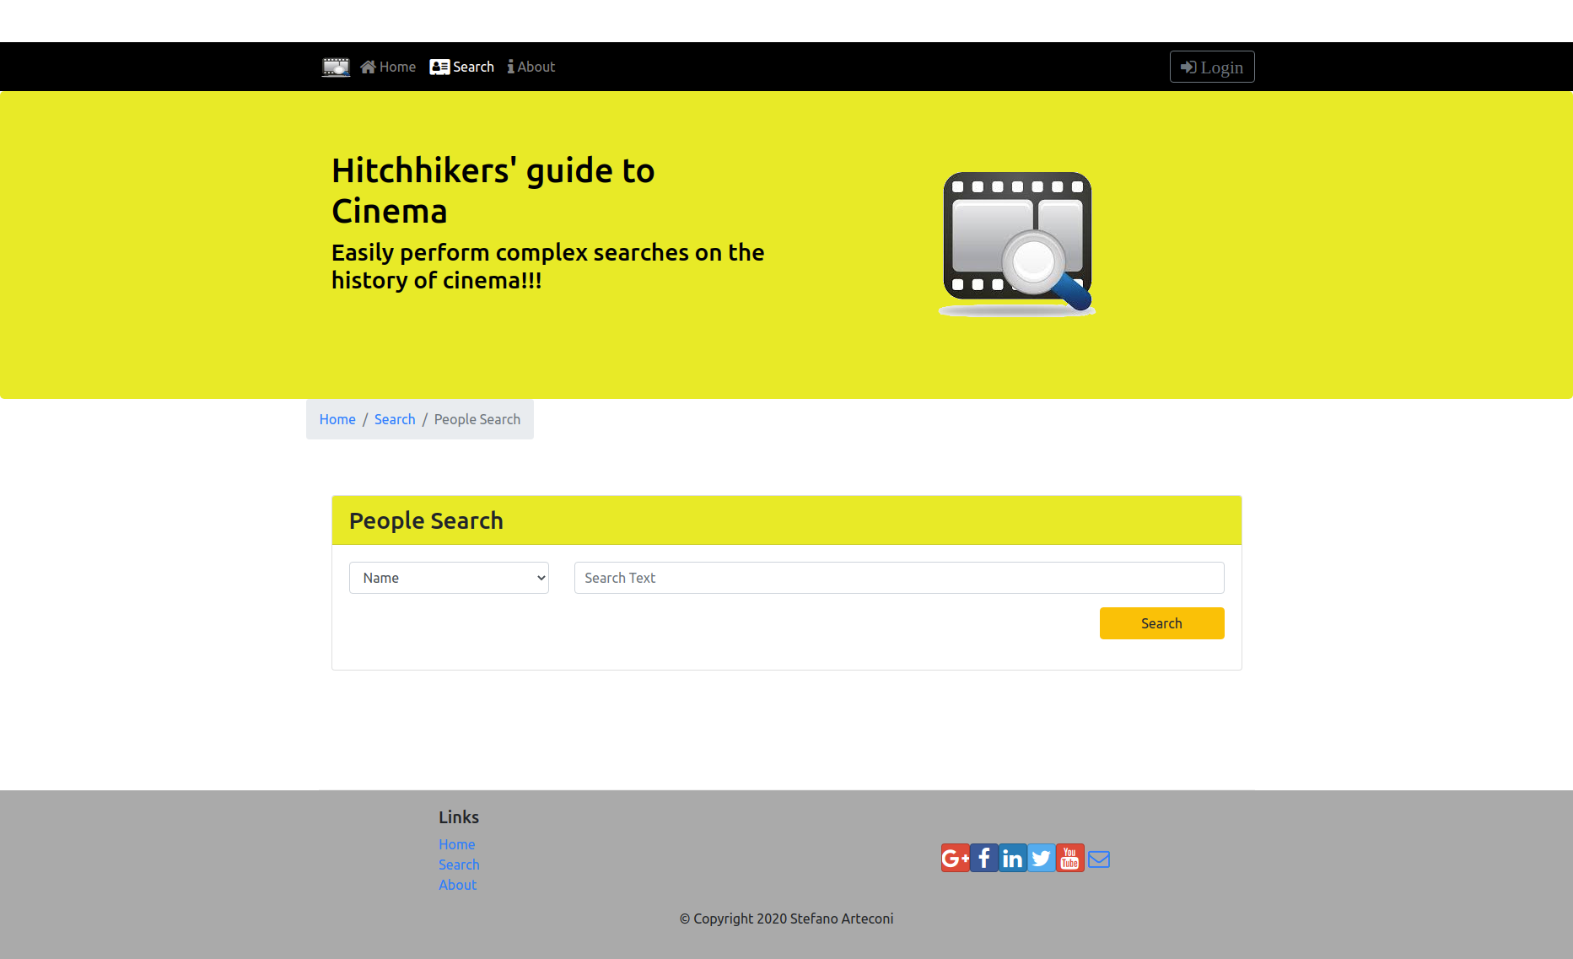

Conclusions
The main result obtained is that H2GC is not a static proof of concept web-page anymore, on the contrary, even though with limited prototyping data, it is now a fully functional single page app, fetching data from a minimal Rest API (obtained manually by querying IMDb Rest API and creating a minimal db) and presenting the data fetched by dynamically loading react components.

References
- Previous bootstrap version deployed at: http://sterte.rf.gd/h2gc/
- Current React version deployed at: https://h2gc-react.web.app/
  - Current prototyping Rest API available at: https://my-json-server.typicode.com/sterte/h2gc-api/
- Source code and docs available at: https://bitbucket.org/sterte/h2gc/src/master/
- IMDb web page: https://www.imdb.com/
  - IMDb advanced searches section: https://www.imdb.com/search/
- IMDb Rest API: https://rapidapi.com/apidojo/api/imdb8

